Asg4 Bug 2 Log

H0: Problem is in UI before returnBookControl.bookscanned(barcode) is called.

T0: Check bookbarcode – barcode is not correct i.e. not equal entered ID

R0: bookbarcode == entered ID

H0 is false - problem is not in UI before returnBookControl.bookscanned(barcode)

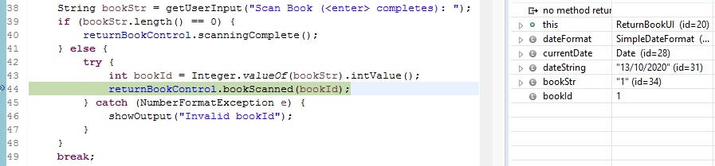

**Bug2SimplicationTest:**

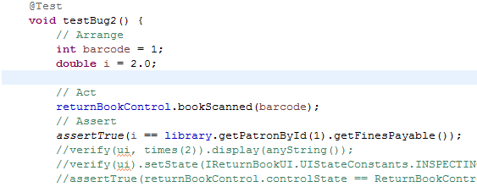

H1: returnBookControl.bookscanned(barcode) executed properly

T1: check whether patron has incurred a $2:00 fine for a two-day overdue loan.

R1: Patron incurred no fines

H1 is false – problem is in returnBookControl.bookscanned(barcode)

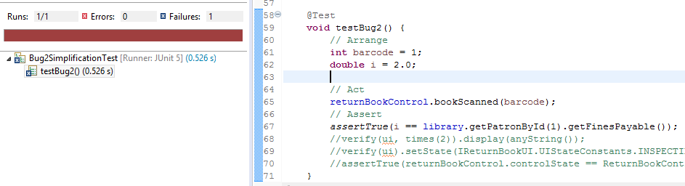

H2: problem is contained in library.calculateOverDueFine

T2: Check whether library.calculateOverDueFine returns 1.00

R2: library.calculateOverDueFine returned 1.00

H2 is True - problem is contained in library.calculateOverDueFine

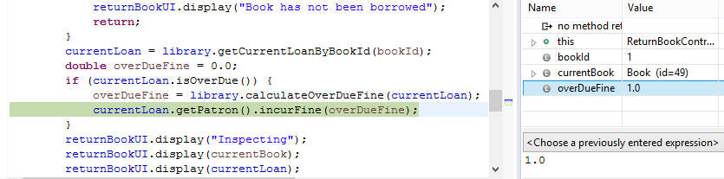

H3: problem is contained in Calendar.getInstance().**getDaysDifference**

T3: Check if daysOverdue variable is not 2

R3: daysOverdue == 1

H3 is True - problem is contained in .**getDaysDifference**

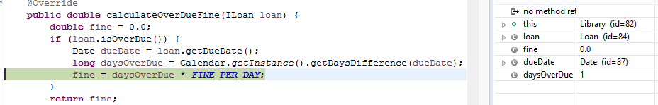

H4: problem is with calculation of **long** diffMilliseconds = getDate().getTime() - targetDate.getTime();

T4: Check if diffMilliseconds != 172800000*

*Two days is equal to 172800000 milliseconds.

R4: diffMilliseconds == 172800000

H4 is False – problem is not contained within diffMilliseconds calculation

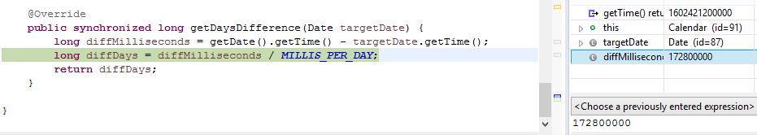

H5: problem is with diffDays calculation

T5: Check if diffDays == 1

R5: diffDays == 1

H5 is True – Problem is within diffDays calculation

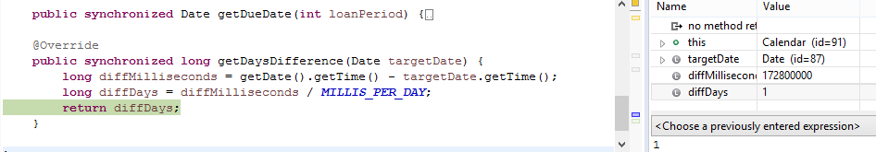

/* Bug1 origin detected ***MILLIS_PER_DAY*** = 172800000L;**

** 172800000 milliseconds = 2 days, therefore diffDays = 1

H6: Changing line 10 in Calendar.java ***MILLIS_PER_DAY*** = 86400000L; will result in diffDays calculation operating correctly – returning 2

T6: change line - diffDays calculation should return

R6: diffDays == 2

H6 is True - diffDays calculation returns intended result

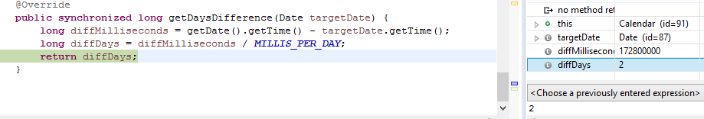

H7: Changing MILLIS_PER_DAY to equal 86400000 will resolve problem

T7: Run simplification test – should execute correctly – Test should pass

R7: Test passes

H7 is True - Changing MILLIS_PER_DAY to equal 86400000 resolves problem

